[cover sheet]

3

ASSIGNMENT 3

**CYCLOMATIC COMPLEXITY, PHASE 2**

CSE 6329 -- SOFTWARE MEASUREMENT AND QUALITY ENGINEERING

Professor Dennis J. Frailey

**Fall, 2019**

|  |  |
| --- | --- |
| NAME | STUDENT ID NUMBER |
| **Balaji Gurumoorthy** | **1001680348** |
| **Goutami Padmanabhan** | **1001669338** |

|  |  |
| --- | --- |
| **Name of Program Evaluated** | **Discussion of Any Errors Found and How to Correct Them** |
|  | 1. For Case 1: Mean=Median i.e. even size input, eg: 3,6,2,1,4,5 we get a really large number as output for Variance and Standard Deviation. Variance = 21703564768751286979531445895168.00 is wrong. The mean logic is written after the standard deviation logic which is wrong.   Solution: The above error can be rectified by putting the mean logic before all the other logic in the program.  Variance has been calculated as **var = var + pow((outArray[i] - temp), 2)**; Here ‘temp’ variable has only initialized float value. Eventually the logic for standard deviation i.e. sd = sqrt(var); also fails.  The mean should be calculated first before calculating variance and standard deviation. The same mean should be used for variance i.e. the variance should be **var = var + pow((outArray[i] - mean), 2)**;   1. For Case 2: Mean=Median i.e. odd size input, eg: 3,6,2,1,4,5,6 we get the same error and the output for Variance and Standard Deviation is a large value as mentioned before.   Solution: The logic implemented should have Mean calculation before variance and standard deviation and same mean should be used for variance i.e. the variance should be **var = var + pow((outArray[i] - mean), 2)**;   1. In All Cases tested, the variance and Standard deviation values have the wrong output value.   Solution: The error can be rectified by calculating mean before all the logic implemented in the program.  Then replace the line  **var = var + pow((outArray[i] - temp), 2)**;  with  **var = var + pow((outArray[i] - mean), 2)**; |

|  |  |  |  |  |
| --- | --- | --- | --- | --- |
| **Cyclomatic Complexity Calculation** | | | | |
| **Arcs** | **Nodes** | **C (Number of Separate Flowgraphs)** | **Arcs - Nodes** | **Arcs – Nodes + 2C**  **(Cyclomatic Complexity)** |
| 32 | 24 | 1 | 8 | 10 |

**Place flowgraph on next page.**

**Flow Graph:**

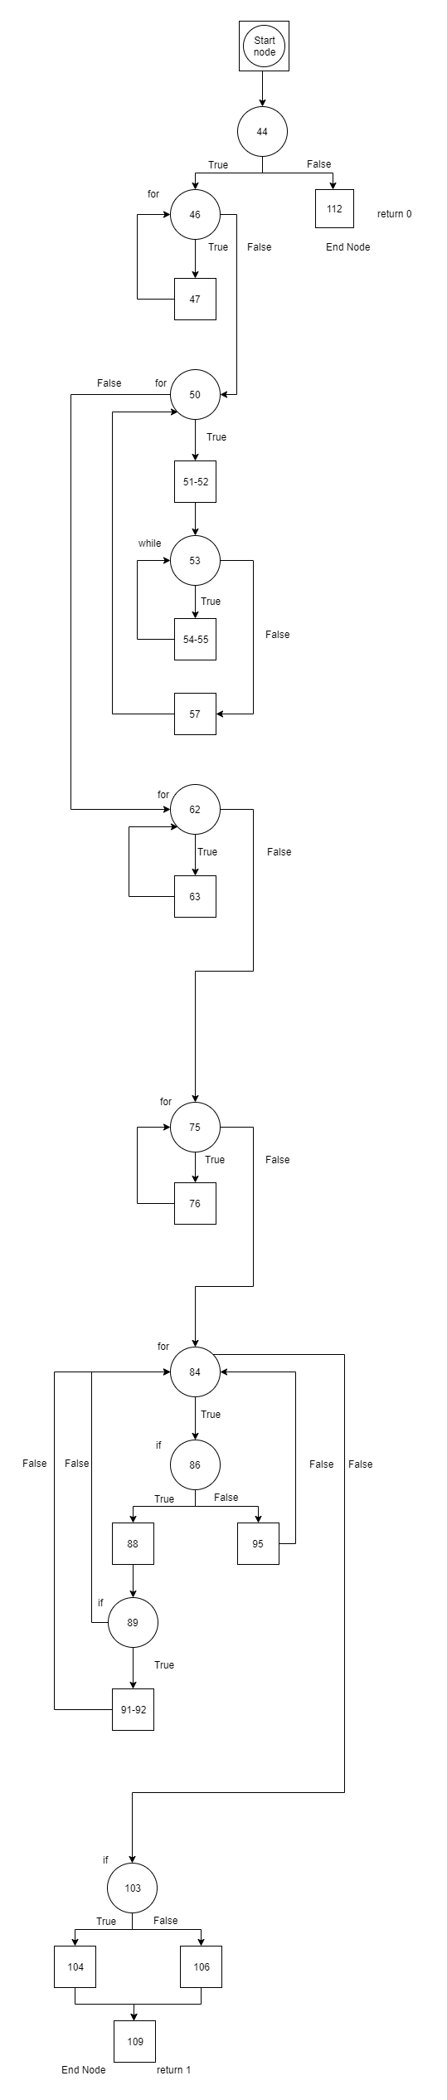

**Cyclomatic Complexity:**

**Number of Edges (e): 32**

**Number of Node (n): 24**

**Number of Separate Flow Graphs (C): 1**

Cyclomatic Complexity of Main Function = e-n+2C

= 32-24+2*1

= 8+2

= **10**